SPEEDTEST MODULE

Part A: Website Design
UI-kit using design tools
Create a UI-kit of the following elements: text box, button, drop-down list, checkbox, radio button, label with checkbox, label with radio button, drop-down calendar input, range, progress bar

Part B: Layout
CSS Grid
Please implement the following layout in CSS grid.
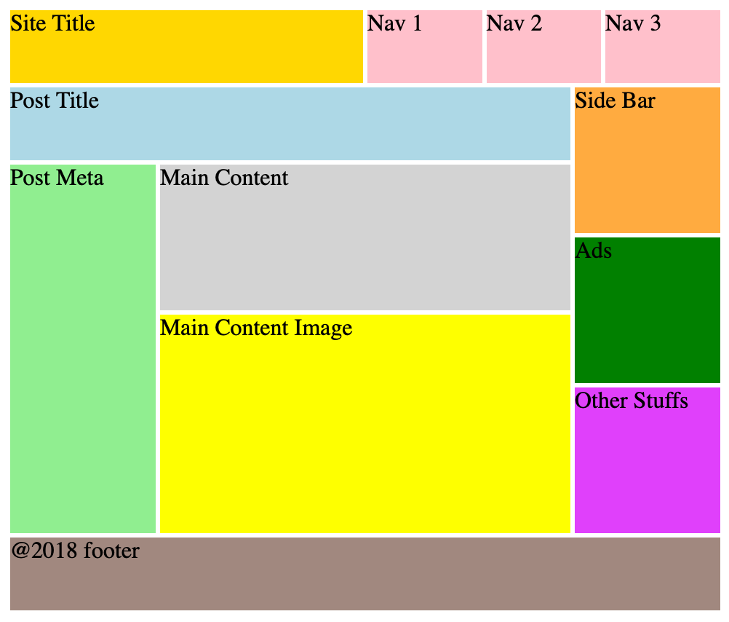

Part C: Front-End Development
RGB Slider
Please implement an RGB slider as following. There are 3 sliders for adjusting values of red, green and blue.
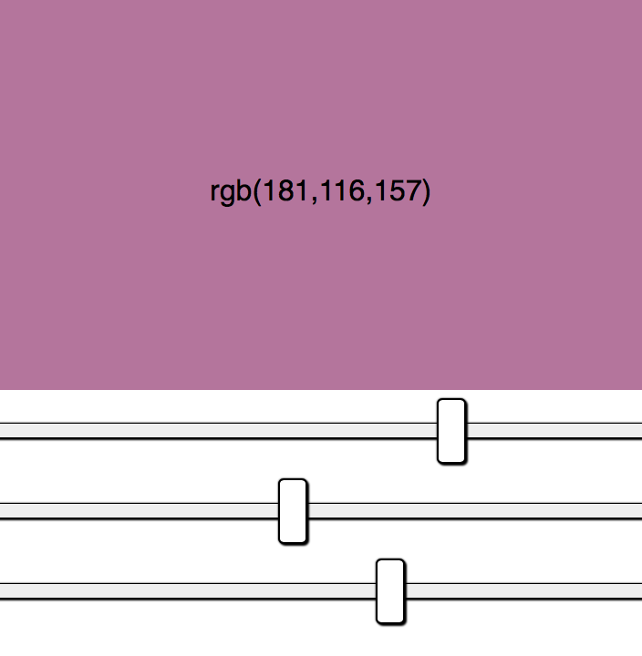

Part D: Back-End Development
PHP Verification captcha

Please use PHP to produce verification code image (captcha), which must comply the following rules (please see the provided images):
a. It randomly generates four characters, consisting of English Alphabet (A-Z) or digit numbers (0-9).
b. The four characters must be slightly rotated.
c. The four characters must not be located at the same row.
d. The image contains at least 3 random lines.
e. At least 3 mixed noise points.

Part E: Content Management Systems
CMS Administration
Set up a wordpress site with several credential listed below:
- Username: admin
Password: LKSN2020
Role: admin
- Username: irfan_LKS
Password: irf4n_Gan$
Role: editor

Instruction for Competitors
Save your files in your root directory on the server called "module_speedtest". Inside that folder create a folder for each part (A-E).

